NLCC #48 MI’KMAQ
SLT(NL Suzy Teubner - Commanding Officer
Email: nlccmicmac@gmail.com Website: http://www.nlccmicmac.ca

Monthly Routine Orders - January 2024

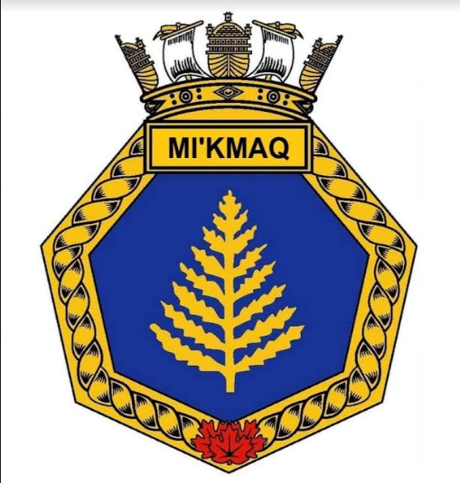

SECTION A – DUTY DIVISION

Date | Activity | Dress | Duty Division
11 Jan | COs Rounds  Bring a Friend Night | Cadets - full uniform  Officers - winter dress | Division 1
18 Jan | Regular Training | Cadets - work dress  Officers - work dress | Division 2
19 Jan | Marksmanship Course  HMCS Scotian | Cadets - civilian dress  Officers - civilian dress | Division 1
25 Jan | Drill/ Supply Night  HMCS Scotian | Cadets - work dress  Officers - work dress | Division 2
26 Jan | Skating @ the Oval | Cadets - civilian dress  Officers - civilian dress | n/a
27 Jan | NSMD Skills Day  HMCS Scotian | Cadets - work dress  Officers - work dress | n/a

SECTION B - GENERAL
Fundraising:
Thank you to all the families that supported our fundraising efforts. Together, we raised $1020.00 for our corps.

We have two upcoming fundraisers planned to support the purchase of marksmanship equipment and band equipment. Starting 11 January 2024, we will run a cotton candy fundraiser. In March, we will run a Cape Breton Fudge fundraiser.

We appreciate the support of our families in these fundraisers. Watch for a separate email about the Cotton Candy fundraiser.

Friday Night Training:
Starting this month, we will be adding an extra training night. Two Friday nights a month we will be training at HMCS Scotian. This training will focus on marksmanship and band during the months of January through March. Later in the year, we will use this time to prepare for our annual inspection.

Marksmanship Training:
NLCC Mi’kmaq Staff are pleased that our marksmanship training program will be starting this month. Marksmanship training is an optional part of our training program and is not required for cadet promotions. This training will take place on Fridays at HMCS Scotian. Please see the schedule above.
Cadets MUST have a completed permission slip to attend the training. Cadets MUST complete a two hour classroom training course prior to being permitted to participate in the training.
The permission slip can be found on the corps website.
Band:
NLCC Mi’kmaq Staff are pleased that we will be offering our cadets an opportunity to be part of the corps band. We will be only the 2nd Navy League corps in the Maritime Provinces to have a band.
Band training will begin in February as we are in the process of purchasing the equipment this month. A/SLt(NL) Smith will be the Band Officer for this training year.
The corps will be starting with the basics, drums.
More information will be sent out to cadets once the equipment has arrived.

Permission Slips:
Permission slips are required for any events that take place outside of our LHQ (Local HeadQuarters), which is Emmanuel Church Hall/ HMCS Scotian.
Our permission slips will be accessible online through our website – www.nlccmicmac.ca – they can be found under the Notices tab.
Parents/guardians are asked to complete the permission slip by 8:00pm the night before the outing.

Parking:
Parents/guardians are reminded that vehicles MUST be parked in one of the clearly marked parking spots.

SECTION C – UPCOMING TRAINING & EVENTS
11 January 2024 Bring a Friend Night
Cadets are asked to bring a friend that may be interested in joining our corps.
Cadets who bring a friend will have their name entered into a draw.

19 January 2024 Marksmanship Course
HMCS Scotian
Timing: 6:20 - 8:30 pm
Permission slip required.

25 January 2024 Drill/ Supply Night
HMCS Scotian
Timing: 6:20 - 8:30 pm

26 January 2024 Skating @ the Oval
Emera Oval
Drop off: 6:45 pm
Pick up: 8:00 pm
Equipment: Parents/guardians can rent equipment for their children.
All cadets MUST wear a helmet.
Permission slip required.

27 January 2024 NSMD Skills Day
HMCS Scotian
Drop off: 8:45 am
Pick up: 3:45 pm
Dress: work dress
Lunch will be provided, cadets should bring a water bottle and snacks.

SECTION D - ADMINISTRATION
CORPS STRENGTH
CADETS | OFFICERS | CIVILIAN INSTRUCTORS
55 | 3 | 6

CONTACTS
Commanding Officer: |  | SLt(NL) Suzy Teubner |  | suzyteubner@navyleagueofcanada.org
Executive Officer  Training Officer: |  | A/SLt(NL) Mathew Smith |  | nlccmicmac@gmail.com  nlccmicmac@gmail.com
Administration Officer: |  |  |  | nlccmicmac@gmail.com
Stores Officer  Divisional Officers  Instructors |  | CI Yuan  CI Vichnevetskaia  CI Harnden  CI Li  CI Harris  CI Reese  SLt(NL) Lake |  | nlccmicmac@gmail.com
Army Cadet Volunteer |  | MWO A Smith  Sgt Situ  Sgt Zhong
Webmaster: |  | Erica Smith
Parent Helpers

Branch President |  | Ursula Kellum |  | navyleaguehfx@gmail.com
Branch/ NL Corps Liaison |  | Erica Smith |  | ericasmith@navyleagueofcanada.org

